**Day 1: Metric Conversions**

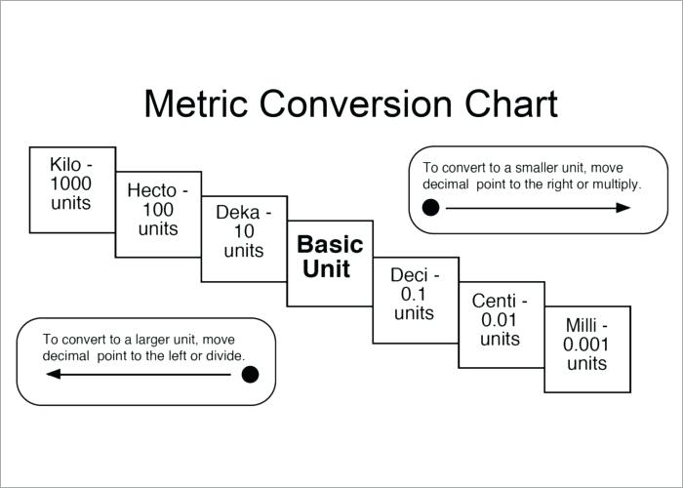

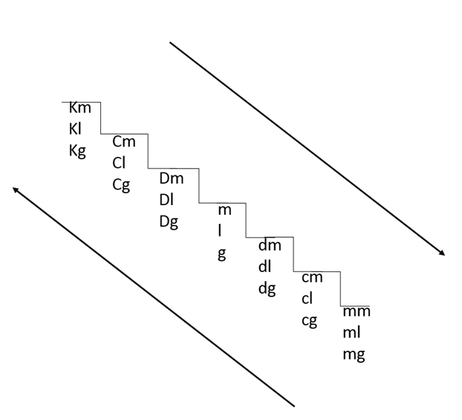

**Convert the following measurements to their required units below:**

1. 3 cm = _______ mm a. 3 mm = ________ m
2. 4 km = _______ m b. 4 cm = ________ Dm
3. 5 dl = ________ ml c. 5 dm = ________ Cm
4. 6 Dm = _______ cm d. 6 dl = _________ Kl
5. 7 Cl = ________ cl e. 7 Cl = _________ Kl

**/ 10 marks**

**Day 1: Measuring Mass**

**Mass** is a basic property of all matter (stuff in nature). All matter is made up of microscopic particles called *atoms* and *molecules*. The mass of an object is a measure of the number of particles in the object and the types of particles in the object. The unit of measurement for mass is grams (**g**) or kilograms (**Kg**).

**Weight** and mass are often confused in common speech. On Earth, weight of an object is due to both its mass and gravity of the Earth. In space, where there is little or no gravity, an object may be weightless but will still have all of its mass.

1. Which of your objects seems to have the greatest weight?
2. In space, will the mass of your objects increase, decrease or stay the same?

**Part 1 Data Table: Mass of Objects**

|  |  |  |  |  |  |  |
| --- | --- | --- | --- | --- | --- | --- |
| **Object** | **Description** | **Beam Balance #1**  **(Mass in g)** | **Beam Balance #2**  **(Mass in g)** | **Electronic Scale**  **(Mass in g)** | **Average Mass (g)**  **(show calculation)** | **Marks** |
| #1 | (1) | (1) | (1) | (1) | (2) | **/ 6** |
| #2 | (1) | (1) | (1) | (1) | (2) | **/ 6** |
| #3 | (1) | (1) | (1) | (1) | (2) | **/ 6** |

**Beam Balance:** Write a procedure and provide a diagram for measuring the mass of an object using a beam balance. Number all your steps.

**/ 3**

**Electronic Scale:** Write a procedure and provide a diagram for measuring the mass of an object using an electronic scale. Number all your steps.

**/ 3**

**Day 1 Total: / 34 marks**

**Day 2: Measuring Volume of a Regular Shaped Solid**

**Volume of a Regular Solid** such as a cube or rectangular prism can be calculated using a formula such as:

Volume = Length x Width x Height

Volume is measured in cubic centimeters (cm3) for solids or milliliters (ml) for liquids. The measurement of 1 cm3 is the same as 1 ml.

**Measurement Units**: Our rulers have measurement markings in both cm (centimeters) and mm (millimeters). Using the fact that 10 mm is equal to 1 cm, complete the following conversions.

10.0 cm = _______ mm (1) 22 mm = _______ cm (1) 2 mm = ________ cm (1)

A rectangular prism has the following dimensions: 10 cm by 4 cm by 2 cm. What is the volume of this prism? Show your calculations below. (2 marks)

**Part 2 Data Table: Volume of Regular Solids**

|  |  |  |  |  |  |  |  |
| --- | --- | --- | --- | --- | --- | --- | --- |
| **Object** | **Description** | **Using a Ruler** | | | | |  |
| **Length (cm)** | **Width (cm)** | | **Height (cm)** | **Volume (cm3) (show calculations)** | **Marks** |
| #1 | Use the same object as for Part 1 | (1) | | (1) | (1) | (2) | **/ 5** |
| #2 | Use the same object as for Part 1 | (1) | | (1) | (1) | (2) | **/ 5** |
| #3 | Use the same object as for Part 1 | (1) | | (1) | (1) | (2) | **/ 5** |

**Calculating Density**

**Density** is a physical property of matter and depends on the type of particles that make up the material or type of matter.

**Density Calculations:** Complete the table below for your sample materials.

|  |  |  |  |  |  |
| --- | --- | --- | --- | --- | --- |
| **Object** | **Description** | **Average Mass (g)**  **(from part 1)** | **Average Volume (cm3)**  **(from part 2)** | **Calculated Density (g/cm3)**  **(using d = m / v)** | **Marks** |
| #1 | Use the same object as for Part 1 and Part 2 | (1) | (1) | (2) | **/ 4** |
| #2 | Use the same object as for Part 1 and Part 2 | (1) | (1) | (2) | **/ 4** |
| #2 | Use the same object as for Part 1 and Part 2 | (1) | (1) | (2) | **/ 4** |

|  |  |
| --- | --- |
| **Material** | **Density (g/cm3)** |
| Air | 0.0012 |
| Styrofoam | 0.075 |
| Wood | 0.700 |
| Ice | 0.917 |
| Oil | 0.942 |
| Water | 1.000 |
| Plastic | 1.175 |
| Glass | 2.500 |
| Aluminum | 2.700 |
| Diamond | 3.500 |
| Zinc | 7.000 |
| Steel | 7.830 |
| Nickel | 8.900 |
| Copper | 8.940 |
| Lead | 11.340 |
| Gold | 19.320 |

**Density Predictions:** Use the table to the right to predict the material of each of your objects.

* 1. Object #1 Predicted Material: ______________________________ (1)
  2. Object #2 Predicted Material: ______________________________ (1)
  3. Object #3 Predicted Material: ______________________________ (1)

**Day 2 Total: / 35 marks**

**Day 2: Density Worksheet**

**UNITS OF DENSITY**  
g/cm3  or g/ml

**Density** = _mass_   
 volume

m

V

D

1. Find the unknown quantity.

|  |  |  |
| --- | --- | --- |
| a. D = ?  V = 950 ml  m = 95 g  (2) | b. D = 3 g/ml  V = 100 ml  m = ?  (2) | c. D = 0.5 g/cm3  V = ?  m = 20 g  (2) |

1. Find the unknown quantity (CONVERT FIRST to g or ml).

|  |  |  |
| --- | --- | --- |
| a. D = 24 g/ml  V = 1.2 L = _________ ml  m = ?  (3) | b. D = ?  V = 100 ml  m = 1.5 kg = __________ g  (3) | c. D = ?  V = 0.52 L = ________ ml  m = 500 mg = ________ g  (4) |

**WORD PROBLEMS**

1. A block of aluminum occupies a volume of 15.0 ml and has a mass of 40.5 g. What is its density? (2)
2. A rectangular block of copper metal has a mass of 1896 g. The dimensions of the block are 8.4 cm by 5.5 cm by 4.6 cm. From this data, what is the density of copper? (Hint: Find the volume of the block first.) (3)

1. Mercury metal is poured into a graduated cylinder that holds exactly 22.5 ml. The mercury is used to fill the cylinder has a mass of 306.0 g. From this information, calculate the density of mercury. (2)

**Worksheet Total / 23 marks**